

**东莞农商**

Instinct

Application Fraud Detection Solution

申请欺诈侦测解决方案

**Business Specification**

**业务说明书**

Version 1.0

2 Sep2016

##### Document Version Control

| **Version** | **Date** | **Author** | **Comments** |
| --- | --- | --- | --- |
|  |  |  |  |
|  |  |  |  |
|  |  |  |  |
|  |  |  |  |
|  |  |  |  |

##### Table of Contents

**目录**

1. Introduction简介 4

1.1 Business Processing Environment业务处理环境 5

1.2 Business Requirements业务需求 6

2. System Architecture系统架构 12

2.1 Functional Overview功能概述 13

2.2 Instinct Interface/File Processing ModesInstinct接口/文件处理模式 15

2.3 Input to Instinct Instinct导入文件 16

*2.3.1* *Input Format输入格式* 16

*2.3.2* *Input Record Layout 输入记录字段定义规范* 19

*2.3.3*  *Company Name Suffix Table* 19

2.4 Output from Instinct导出文件 20

*2.4.1* *Output Format输出格式* 20

*2.4.2* *Output Record Layout输出记录字段定义规范* 20

*2.4.3* *Error Table错误表* 22

2.5 Lookup Tables巡查表 23

3. Functional Requirements功能需求 24

3.1 Application Menu申请菜单 24

3.2 Definitions Menu定义菜单 27

3.3 Criminal Menu欺诈申请菜单 31

3.4 Information Menu信息菜单 33

Applications Pending Follow-up未进行欺诈确认申请信息 35

Fraud Score Analysis欺诈积分分析 40

3.5 Security Menu安全菜单 48

3.6 System Options系统选项 56

3.7 Online Help在线帮助 69

Sign-off 70

1. Introduction简介

Instinct is an application fraud detection solution by DecTech Solutions.

Instinct 是DecTech Solutions用于侦测欺诈行为的解决方案。

Instinct detects application fraud in two ways. Firstly, by comparing the details of all new credit applications against a database of known fraudsters (the Criminal Database), applications from known offenders can be identified. The Criminal Database is a repository of data within Instinct which can store information about blacklisted and watchlisted individuals, companies, salespersons and any other entities that could be involved in credit applications. The information in the Criminal Database will be obtained from the Client’s own sources and it will be built up on an ongoing basis through the use of the system.

Instinct通过两种方式来侦测欺诈申请行为。方式一，Instinct会将所有的新的信贷申请的详细信息和欺诈数据库中已存在的欺诈数据进行比较，从而识别出来自已知欺诈者的申请记录。欺诈数据库是Instinct的数据仓库，它用于保存黑名单和其关注的个人、公司、销售人员和其他任何跟信贷申请相关的实体。欺诈数据库中的信息从客户自己的来源来获取，并且在使用中逐渐积累完善。

Secondly, by comparing the details of all new applications against all other new and recent applications (usually the last 6 months to 2 years), applications containing suspicious information can be identified.

方式二：系统将所有新申请和其他新的或最近发生的申请（通常指最近6个月到2年发生的申请）进行比较，从而识别出包含可疑信息的申请记录。

Instinct is a Windows based client server application.

Instinct是基于Windows的客户端/服务器应用程序。

This specification details the business requirements for the Instinct implementation at DRC in China.

本手册将详细描述东莞农商对Instinct的使用需求。

DRC’s application processing system (APS or Small Loan System) will be interfaced to Instinct for application fraud checking applications.

东莞农商的申请处理系统（小贷系统）会通过接口连接Instinct来对申请做申请欺诈检查。

Business Processing Environment业务处理环境

DRC will use real time mode to interface Instinct, but will keep the batch mode as well.

东莞农商会使用Instinct的实时模式, 但是也会保留批量模式。

When the APS of DRC.COM calls Instinct, Instinct will return the fraud alert: H (HFP), S (Suspect) or C (Clean). For H and S applications, APS will hold these application and investigator will review them and action them in Instinct Client and then Instinct will return the result to APS. So APS need to develop a Web Service, Instinct will call the web service to return the action result to APS. The action result could be Known Fraud, Suspicious, Under Investigation and False Positive. For false positive, APS will continue the workflow and for known fraud, APS will reject the application.

当东莞农商的申请审批系统调用Instinct，Instinct会返回欺诈报警：H（高风险），S（疑似）或者C（清白）。对于H或者S的申请，审批系统会挂起这部份申请，调查人员会在Instinct客户端浏览这些申请并人工做出判定。判定结果Instinct会返回给申请审批系统。判定可能为“确认欺诈”，“疑似欺诈”，“在调查中”和“清白”，对于清白申请，申请审批系统会继续流程而对于“确认欺诈”申请，审批系统会拒绝该申请

APS need to develop 3 interfaces:

审批系统需要开发3个接口：

1. Calling the Instinct Web Service.

调用Instint的实时接口

1. Generate the Instinct batch file and send the file to a specific folder on Instinct Server.

生成Instinct批量文件并把批量文件送到Instinct服务器上的指定目录下。

1. Create a Web Service: Instinct can call this Web Service that returns the action of investigator.

创建一个Web Service：Instinct会把调查人原的判定结果返回给审批系统。

DRC will export their blacklist into Instinct according to Instinct format and load into Instinct.

东莞农商可以把现有系统中的黑名单按照Instinct的格式导出，然后装载进Instinct。

DRC will export all blacklist records in 1 file before production.

东莞农商会在上线前一次性导出所有的黑名单记录。

Instinct has nearly 30 standard reports and can provide SQL reports if they need customized reports.

Instinct有接近30张标准报表，并且如果客户需要，可以提供SQL报表。

Business Requirements业务需求

DRC have identified the following business requirements to be addressed as part of the implementation of Instinct in China:

东莞农商确定下列业务需求作为Instinct实施的一部分：

* To reduce fraudulent applications;

减少欺诈申请

* To undertake faster action to minimise fraud losses;

采取更快的行动来减少欺诈损失

* To identify and prevent syndicate, small-time, third party and internal application fraud, and first payment default;

侦测和阻止集团欺诈，短时间内多次申请欺诈，第三方欺诈和内部欺诈和第一次还款违约

* To automatically run all credit card applications through a fraud check prior to credit decision;

在信用决定前，对所有信用卡申请进行欺诈检查

* To enable the fraud reviewer to carry out fast investigation and database interrogation;

帮助欺诈浏览人员更快的的调查和数据库访问

* To have the ability to change fraud rules and strategies instantly;

能即时的修改规则和策略

* To enable the fraud analyst to focus on the high risk and suspicious applications first;

帮助欺诈分析员首先关注于高风险和疑似欺诈

* To prevent repeat offenders by utilising and maintaining a detailed database of known frauds;

通过使用和维护详细的已知欺诈数据库来防止重复申请欺诈

* To ensure that the organisation is not an easy target for fraud – fraudsters target organisations where they know they can easily get credit approved fraudulently. If an organisation has strict fraud control in place, then fraudsters will instead target other financial services institutions

降低银行的欺诈风险，从而在行业中具有更强的竞争力-对于欺诈者的目标银行，他们知道他们靠非法手段能轻易的获取到信贷核准。假如一个银行有严格的欺诈控制，这时欺诈者就会把目标转到另外的银行

* To document fraud cases centrally and thoroughly – Instinct can be used as the central database for all types of fraud. Fraud cases can be stored electronically so that if some applications details match the fraud case in the future, it is easy for the fraud reviewer to review the details of the previous fraud case.

集中并详细的纪录欺诈案件-对所有类型的欺诈，Instinct能作为核心数据库来储存欺诈案件。如果将来某些申请细节满足欺诈案件，欺诈审查员就可以轻易的查看前一笔欺诈案件的细节

* To continually improve application fraud prevention strategies – Instinct can be used to test new fraud rules in the production environment, and experiment with new fraud rules to detect new types of application fraud. All the reporting is built into Instinct so that rules can be continually improved.

可以持续改进企业应用欺诈保护策略- 在生产环境中，Instinct能用来测试新的欺诈规则和用新欺诈规则来试验侦测新类型申请欺诈。所有的报告都内置于Instinct中，这样规则就可以被持续的改进。

The version of Instinct to be implemented at DRC in China is version 4.7.2.

在东莞农商实施的Instinct版本是4.7.2

In terms of blacklist checking in Instinct, DRC will clean up their blacklist and then load it into Instinct. DRC will do the blacklist cleanup in their own system.

使用Instinct中的黑名单检查，东莞农商会清洗他们的黑名单并导入进Instinct。东莞农商会在他们自己的系统中清洗黑名单。

DRC will have the following Site with special Functions:

东莞农商的特殊需求函数如下：

Site with Special Functions Code:

Features enabled are:

1. System Architecture系统架构

Windows servers will host the Instinct database and Instinct server applications.

Instinct数据库服务器和应用服务器使用Windows Server平台。

Instinct clients will be installed for users in the credit processing department and the fraud prevention department. The client software will be used by the credit processing department users to review and action fraud alerts. The client software will also be used by the fraud prevention department users to maintain the criminal database, maintain their system parameters, fraud rule definitions etc.

Instinct客户端供信用处理部门和欺诈防护部门的员工使用。信用处理部门的用户用Instinct客户端软件来检查和判定欺诈警报。欺诈防护部门的员工使用Instinct客户端软件来维护欺诈数据库，维护系统参数和欺诈规则定义等。

## Functional Overview功能概述

The following diagram shows a high level overview of how Instinct does application fraud checking. DRC’sSales Systemwillinterface to Instinct inreal timemode.

下图概述Instinct如何完成欺诈检查。东莞农商的Sales System如何通过实时模式与Instinct连接。

Instinct loads each application into the Application Database. Then for that application, Instinct applies the fraud scoring, fraud rules and fraud alerts (to do this it uses the Criminal Database, all the other applications on the Application Database and also the reference tables).

Instinct将每个申请记录导入到申请数据库中。然后针对该笔申请， Instinct将通过评分卡、欺诈规则以及欺诈报警等系统定义的参数信息进行欺诈检查。（Instinct通过搜索欺诈数据库和在申请数据库中的所有其他申请数据来执行该过程。）

The fraud check will result in one of three outcomes – HFP (High Fraud Potential), Suspect or Clean.

欺诈检查有三种结果—高风险（高的欺诈可能），疑似欺诈和清白。

HFP and Suspect applications will need to be reviewed, investigated and actioned by the fraud reviewer through the Instinct client workstation. Clean applications may also be actioned – for example, a clean application may be found to be fraudulent or suspicious via an auto-fraud check, or it may be found to be fraudulent outside of Instinct (e.g. a fraud document) and therefore actioned as fraud.

高风险和疑似欺诈申请需要被审核，调查和判定确认，这些判定可以依靠欺诈操作员通过Instinct的客户端工作站完成。清白申请可能也会被判定–例如：清白申请可能被发现欺诈或者疑似通过自动欺诈检查，或者通过其他方式被发现欺诈（例如：欺诈文件），因此会被判定为欺诈。

When operating in onlinereal time mode, Instinct will send to the calling application the result of the fraud check (HFP, Suspect or Clean) and also, upon actioning the application, Instinct will send the action taken by the user (Known Fraud, Suspicious, Under Investigation or False Positive).

当在实时模式下操作，Instinct会发送申请的欺诈检查结果（高风险，疑似欺诈和清白）。同时对于这笔申请，Instinct会返回用户的判定结果（确认欺诈，疑似，需调查和无欺诈）。

Additionally, it is possible that the user could re-action the application (e.g. in the case of Under Investigation first, followed by False Positive or Suspicious or Known Fraud later), or action a case after an auto-fraud check detects a fraud case (or any other investigation detects a fraud case).

另外，用户可能会重新判定这笔申请（例如：一笔申请现在调查中，后来被确认为无欺诈或疑似或已知欺诈），或者在自动欺诈检查侦测出的一笔欺诈案件（或者任意的其他调查侦测出的欺诈案件）后，判定这笔欺诈案件。



The following diagram shows how the APS will initiate an application fraud check call to the Instinct Web (Application) Server, and the fraud alert will be returned in real time:

下图显示申请处理系统如何调用Instinct的Web Service，且Intinct实时返回欺诈报警。

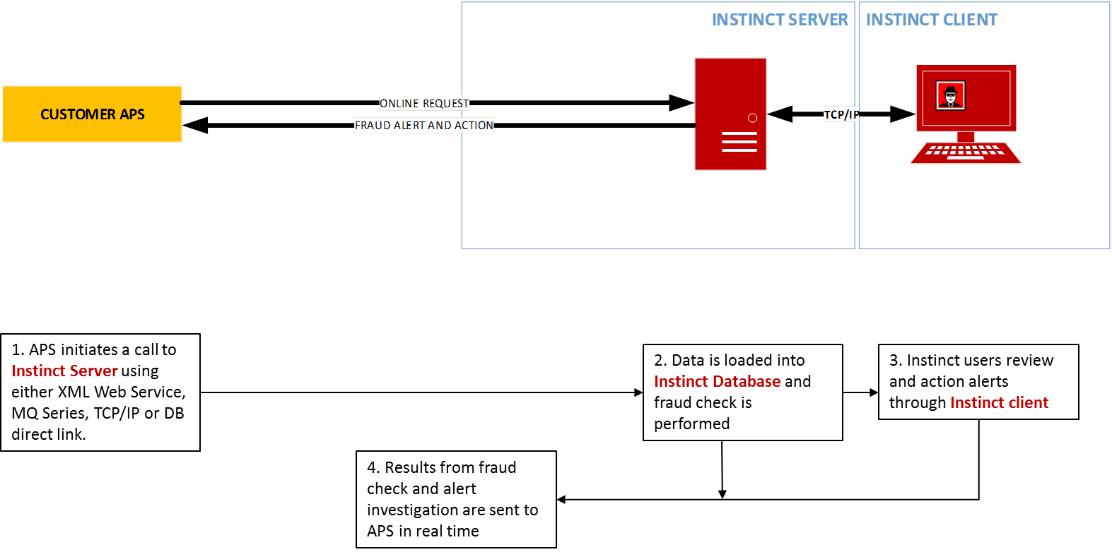

## Instinct Interface/File Processing ModesInstinct接口/文件处理模式

Instinct can be used in both online and batch modes.

Instinct支持在线和批处理两种处理模式。

Online mode is meant for business applications where the timeliness of the fraud check on the application is critical. For example, if the applicant is immediately gaining access to the facility for which they are applying, then the timeliness of the fraud check could be deemed as critical.

在线模式可以处理那些对急需要进行欺诈检测的交易申请行为。例如，如果一个申请人需要立即开通他所申请的交易功能，那么就可以认为急需对该申请进行欺诈检测。

Batch mode is meant for business applications where the timeliness of the fraud check on the application is not critical. For example, if the applicant is not gaining access to the facility to which they are applying until the next day or later, then the timeliness of the fraud check could be deemed as not critical.

批处理模式可以处理那些并不急需进行欺诈检测的交易申请行为。例如，如果一个申请人可以等到明天或更晚时间来开通他所申请的交易功能，那么就可以认为对该申请进行欺诈检测不是急需的。

The following tables show the different ways of interfacing with Instinct:

下表展示了与Instinct交互的不同方式：

|  |  |  |  |
| --- | --- | --- | --- |
| **Type**  **类型** | **Mode**  **模式** | **File**  **Name**  **文件名** | **Purpose** |
| Batch input file  批处理输入文件 | Batch (no output)  批处理（无输出） | B*.txt | 1. Load historical applications.   装载历史申请数据。   1. Batch mode fraud checking.   批处理模式欺诈检查。 |
| Criminal input file  欺诈输入文件 | Batch (no output)  批处理（无输出） | C*.txt | Load criminal records.  装载欺诈记录。 |
| Criminal Deletion file 欺诈删除文件 | Batch (no output)  批处理（无输出） | D*.txt | Delete criminal records.  删除欺诈记录。 |
| Input file 输入文件 | Online  在线 | I*.txt | Online mode fraud checking by placing the file in the input directory.  在线模式欺诈检查，把文件放入输入目录。 |
| XML web service | Online  在线 | N/A | Online mode fraud checking.  在线模式欺诈检查 |
| Reference Files  引用表文件 | Batch  批处理 | R*.txt  R*.csv  R*.xls  R*.xlsx | Loaded reference data into an additional instinct table for rules checking.  装载额外的引用表用于规则检查 |

## Input to InstinctInstinct导入文件

### *Input Format输入格式*

Instinct accepts data as a fixed or variable length text string where data values are separated by the delimiter “|” (vertical bar) – note that this delimiter can be altered in the INI file if required.

Instinct输出数据可以是一个长度固定或者变化的文本。数据值被分隔符|（竖线）分隔-注意：如果需要，此分隔符可以在INI文件中被修改。

In an input file, each application or criminal/known fraud is represented as one record in the file, separated by a carriage return line feed (crlf). Fixed length records must have trailing spaces. Fixed length records are optional for the Instinct Input file.

在一个输出文件中，每一笔申请在文件里表现为一条记录，有回车符分隔。固定长度的记录将尾随空格。Instinct输入格式也可以选择固定长度格式。

One record is broken down into the following categories:

一笔纪录被细分为下列几类信息：

|  |  |
| --- | --- |
| **Category** | **Comments** |
| Application | Each record must contain 1. |
| Applicant | Each record may contain up to 99. |
| Accountant/Solicitor | Each record may contain up to 99. |
| Guarantor | Each record may contain up to 99. |
| Introducer/Agent | Each record may contain up to 99. |
| Reference | Each record may contain up to 99. |
| Security | Each record may contain up to 99. |
| Previous Address/Company | Each record may contain up to 99. |
| Valuer | Each record may contain up to 99. |
| User Category | Each record may contain up to 99. |
| Credit Bureau | Each record may contain up to 99. |
| User 2 Category | Each record may contain up to 99. |
| UCA Category | Each record may contain up to 99. |
| CBA Category | Each record may contain up to 99. |
| U2A Category | Each record may contain up to 99. |
| UCB Category | Each record may contain up to 99. |
| CBB Category | Each record may contain up to 99. |
| U2B Category | Each record may contain up to 99. |
| UCC Category | Each record may contain up to 99. |
| CBC Category | Each record may contain up to 99. |
| U2C Category | Each record may contain up to 99. |
| Diary Notes | Maximum of 10,000 characters. |

Note that only the Application category is mandatory. Therefore if, for example, there is no guarantor for a particular application then no Guarantor category would be included in the record.

注意：只有申请信息分类是必需项。因此，例如：如果对于一笔没有担保人信息的申请，那么担保人信息就不会包含在记录中。

The categories that are included in the record must be in the same order as the table above.

包含在记录的信息类别必须按照上表中的顺序排列。

Null is represented by a consecutive delimiter. Any field can be input as null, except for the following:

数据为空用连续的分隔符表示。除了以下的字段，其他任意的字段能为空。

* Organisation;
* Country Code;
* Application Number (Application records only – for Criminal records, Application Number may be null and a unique number will be auto-generated by Instinct);
* Application Date;
* Application Type (Application records only – for Criminal records, Application Type may be null).

Note: The Criminal record Application Number may be any unique key.

注意：欺诈数据记录申请编号可以是任何唯一的键值。

All Date type fields must be in the format dd/mm/ ccyy.

所有的日期类型域必须是DD/MM/CCYY的格式。

The valid Country Codes are shown in the following table:

下表展示了有效的国家代码：

|  |  |
| --- | --- |
| **Country Code**  **国家代码** | **Country**  **国家** |
| CN | China |

The valid Application Types are shown in the following table:

下表展示了有效的申请类型：

|  |  |
| --- | --- |
| **Application Type**  **申请类型** | **Description**  **描述** |
| PL | Personal Loan |

The valid Nature of Fraud values are shown in the following table:

下表展示了有效的欺诈分类值的

| **Nature of Fraud**  **欺诈分类** | **Description**  **描述** |
| --- | --- |
| 01 | FALSE IDENTITY |
| 02 | IDENTITY THEFT |
| 03 | FALSE RESIDENTIAL ADDRESS |
| 04 | FALSE COMPANY |
| 05 | FALSE EMPLOYMENT |
| 06 | FALSE INCOME |
| 07 | FRAUD RING |
| 08 | FALSE CONTACT DETAILS |
| 09 | CREDIT BUREAU |
| 10 | INTERNAL FRAUD |
| 11 | COLLUSION |
| 12 | FALSE REFEREE |
| 13 | BREACH OF LAW |

Note that new Country Codes can be added to the INI file. Application Types and Nature of Fraud values can be maintained through a user-driven maintenance table.

注意：新的国家代码可以添加进INI文件。用户可以通过维护寻查表来修改申请类型和欺诈分类的值。

### *Input Record Layout**输入记录字段定义规范*

略

### *2.3.3 Company Name Suffix Table*

The following company name suffixes will be set up in Instinct and removed during loading:

公司名称后缀名可以在用户维护表中定义，当数据载入到Instinct中时，后缀名会被移除（之后再做规则匹配）。

|  |
| --- |
| 有限责任公司 |
| 股份有限公司 |
| 集团公司 |
| 集团有限公司 |
| 股份公司 |
| 有限公司 |
| 集团 |
| 分公司 |
| 公司 |

## 2.4 Output from Instinct导出文件

### *2.4.1 Output Format输出格式*

Instinct outputs data as a fixed or variable length text string where data values are separated by the delimiter | (vertical bar) – note that this delimiter can be altered in the INI file if required. The output format is also set in the INI file.

Instinct输出数据可以是一个固定长度或者可变长度的文本字符串。数据值被分隔符|（竖线）分隔—注意：如果需要，此分隔符可以在INI文件中修改。

In an output file, each application is represented as one record in the file, separated by a carriage return line feed (crlf). Fixed length records will have trailing spaces.

在一个输出文件中，每一笔申请在文件里表现为一条记录，用回车符分隔。固定长度的记录将用空格补齐。

### *2.4.2 Output Record Layout**输出记录字段定义规范*

| **Field** | **Type** | **Length** | **Comments** |
| --- | --- | --- | --- |
| Organazation | Text | 3 | Same as input. |
| Country_Code | Text | 2 | Same as input. |
| Group_Member_Code | Text | 4 | Same as input. |
| Application_Number | Text | 25 | Same as input. |
| Capture_Date | Date | 10 | Same as input. |
| Capture_Time | Numeric | 6 | Same as input. |
| Application_Type | Text | 4 | Same as input. |
| Fraud_Score | Numeric | 3 | Will be 0-999. |
| Fraud_Alert | Text | 1 | “H” = High Fraud Potential (HFP) |
| “S” = Suspect |
| “C” = Clean |
| Action_Taken | Text | 1 | Null = No Action Taken |
| “K” = Known Fraud |
| “S” = Suspicious |
| “U” = Under Investigation |
| “F” = False Positive |
| Error_Code | Text | 2 | Refer to Error table. |
| User_Defined_Alert | Text | 10 | If 'UserDefinedAlertInOutputFile' parameter set to 'Y' |
| Decision_Reason | Text | 100 | If 'DecisionReasonInOutputFile' parameter set to 'Y' |
| Action_User | Text | 20 | If 'UserIdInOutputFile' parameter set to 'Y' |
| Rule_Triggered_1 | Text | 3-7 | If 'RulesInOutputFile' parameter set to 'Y' |
| Rule_Triggered_2 | Text | 3-7 |
| Rule_Triggered_3 | Text | 3-7 |
| Rule_Triggered_4 | Text | 3-7 |
| Rule_Triggered_5 | Text | 3-7 |
| Rule_Triggered_6 | Text | 3-7 |
| Rule_Triggered_7 | Text | 3-7 |
| Rule_Triggered_8 | Text | 3-7 |
| Rule_Triggered_9 | Text | 3-7 |
| Rule_Triggered_10 | Text | 3-7 |
| Rule_Triggered_11 | Text | 3-7 |
| Rule_Triggered_12 | Text | 3-7 |
| Rule_Triggered_13 | Text | 3-7 |
| Rule_Triggered_14 | Text | 3-7 |
| Rule_Triggered_15 | Text | 3-7 |
| Rule_Triggered_16 | Text | 3-7 |
| Rule_Triggered_17 | Text | 3-7 |
| Rule_Triggered_18 | Text | 3-7 |
| Rule_Triggered_19 | Text | 3-7 |
| Rule_Triggered_20 | Text | 3-7 |
| Description_Rule_Triggered_1 | Text | 100 | If 'RulesDescriptionInOutputFile' parameter set to 'Y' |
| Description_Rule_Triggered_2 | Text | 100 |
| Description_Rule_Triggered_3 | Text | 100 |
| Description_Rule_Triggered_4 | Text | 100 |
| Description_Rule_Triggered_5 | Text | 100 |
| Description_Rule_Triggered_6 | Text | 100 |
| Description_Rule_Triggered_7 | Text | 100 |
| Description_Rule_Triggered_8 | Text | 100 |
| Description_Rule_Triggered_9 | Text | 100 |
| Description_Rule_Triggered_10 | Text | 100 |
| Description_Rule_Triggered_11 | Text | 100 |
| Description_Rule_Triggered_12 | Text | 100 |
| Description_Rule_Triggered_13 | Text | 100 |
| Description_Rule_Triggered_14 | Text | 100 |
| Description_Rule_Triggered_15 | Text | 100 |
| Description_Rule_Triggered_16 | Text | 100 |
| Description_Rule_Triggered_17 | Text | 100 |
| Description_Rule_Triggered_18 | Text | 100 |
| Description_Rule_Triggered_19 | Text | 100 |
| Description_Rule_Triggered_20 | Text | 100 |
| Diary |  |  | If 'DiaryInOutputFile' parameter set to 'Y' |
| Diary_Date | Text | 10 |  |
| Diary_Time | Text | 6 |  |
| Diary_User_Id | Text | 20 |  |
| Diary_Note | Text | 4000 |  |

### *2.4.3 Error Table错误表*

If Instinct encounters an error in the input data, an error code will be returned to the calling application so that corrective action can be taken. The error will also be shown in the Instinct client. If there was no error then the error code will be null. The following table describes the error codes that may be returned by Instinct:

如果Instinct在导入数据中遇到错误，一个错误代码将返回给调用程序以便用户采取合适的措施。该错误也将显示在Instinct客户端。下表描述了Instinct可能返回的错误代码：

|  |  |
| --- | --- |
| **ERROR CODE**  **错误代码** | **DESCRIPTION**  **描述** |
| 01 | Organisation was null or invalid  组织机构为空或者无效 |
| 02 | Application Number was null or blank  申请书条形码为空或者无效 |
| 03 | Application Date was null or invalid  申请日期为空或者无效 |
| 04 | Application Type was null or invalid  申请类型为空或者无效 |
| 06 | Decision Date was invalid  无效的决定日期 |
| 07 | An invalid Category was detected  检测到无效种类. |
| 09 | Application Type Invalid for Service  对于服务，申请类型无效 |
| 12 | Winsocket error (null data)  Win套接字错误 |
| 13 | Application load error  申请装载错误 |
| 14 | Country code was null or invalid  国家代码为空或者无效 |
| 17 | Applicant user field 7 was invalid  Applicant user field 7 无效 |

## 2.5Lookup Tables巡查表

The following Lookup Tables will be set up in Instinct:

Instinct中创建了下列的巡查表

| **Lookup Table Name : Marital Status** |  |  |
| --- | --- | --- |
| **Category** | **Field** |  |
|  |  |  |
|  |  |  |
|  |  |  |
| **Code** | **Description** | **Active** |
|  |  |  |
|  |  |  |
|  |  |  |
| **Lookup Table Name : Yes No** |  |  |
| **Category** | **Field** |  |
|  |  |  |
|  |  |  |
|  |  |  |
| **Code** | **Description** | **Active** |
|  |  |  |
|  |  |  |

1. Functional Requirements功能需求

None

## Application Menu申请菜单

3.1.1 Review Online Calls在线呼叫浏览

Review Online Calls is used to review applications that have entered the Instinct system in online mode. Fraud reviewers will need to review the HFP and Suspect fraud alert queues, investigate matches, and action applications.

在线呼叫浏览功能可以浏览所有通过在线呼叫系统进入 Instinct 的申请数据。欺诈浏览器可以用来浏览具有高欺诈可能性以及受怀疑的申请记录，并且可以查看匹配情况，确认申请记录的欺诈行为等。

Applications actioned as fraud will be copied to the criminal database.

确认为欺诈行为的申请记录将会被复制到欺诈数据库中。

Any application errors can also be reviewed through this screen.

在此界面中也可以浏览任何申请记录的错误信息。

3.1.2 Review Application Batch Loads浏览批次装载的申请记录

Review Application Batch Loads is used to review applications that have entered the Instinct system in batch mode. Fraud reviewers will need to review the HFP and Suspect fraud alert queues, investigate matches, and action applications.

浏览批次装载的申请记录功能可以浏览所有通过批处理模式进入 Instinct 的申请数据。欺诈浏览器可以用来浏览具有高欺诈可能性以及受怀疑的申请记录，并可以查看匹配情况，确认申请记录的欺诈行为等。

Applications actioned as fraud will be copied to the criminal database.

确认为欺诈行为的申请记录将会被复制到欺诈数据库中。

Any application errors can also be reviewed through this screen.

也可通过此界面浏览任何申请记录错误信息。

3.1.3 Applications Under Investigation在调查中的申请

The Applications Under Investigation window is used to review all the applications that have been actioned as Under Investigation regardless of how they were loaded.

在调查中申请窗口用于浏览被判定为在调查中的申请，不管是通过哪种方式导入进Instinct的。

3.1.4 Organisation Monitoring组织机构监控

Organisation monitoring allows a quick view of the number of applications that have alerted, which team they are assigned to and which user they are assigned to.

组织机构监控提供一个快速的浏览，查看多少申请触发了报警，这些申请被分配到那个小组和用户。

3.1.5 Online Application Maintenance在线申请记录维护

Online Application Maintenance allows the user to add, update and delete applications.

在线申请记录维护功能允许用户增加，修改和删除申请记录。

3.1.6 Application Quick Search快速搜索申请记录

Application Quick Search allows the user to search for applications using screen values, update, delete, action and fraud check applications.

快速搜索申请记录功能允许用户通过界面中的值搜索申请，同时可对检索出的申请数据进行更新、删除、确认和进行欺诈检查等操作。

3.1.7 Application Search Using Criteria使用搜索规则进行申请数据的查询

Application Search Using Criteria allows the user to search for applications using user-defined criteria which is more complex than doing a quick search.、

通过使用搜索规则进行申请数据查询功能可以允许用户使用比在快速搜索中定义的更复杂的查询条件搜索需要的申请记录。

***3.1.8 Application Case Management申请案件管理***

Application Case Management allows the userto link related applications and criminal records using a Case Number for easy review.

申请案件管理允许你使用一个案件编号来链接相关联的申请记录和欺诈记录以便于浏览。

The case management function also allows users to search for cases, maintain a case diary and delink applications and criminal records.

案件管理功能允许用户搜索案件、维护案件和解除申请和欺诈记录。

3.1.9 Application Database Clean-up申请数据库清除

Application Database Clean-up allows the user to export, archive or delete the applications that meet a certain user-defined criteria.

申请数据库清除功能允许用户导出、存档或删除那些通过用户自定义查询规则搜索出的申请数据。

3.1.10 Lock锁

The Locks window is used to review all the applications that have been locked by Instinct and release each application if required.

锁窗口用于浏览所有的被锁住的申请并可以根据需要释放锁住的申请。

3.1.11 Recent Applications最近的申请

Recent Applications menu option allows the users to go back to any of the recent applications accessed by the user. The number of applications displayed is defined in the System Parameters window, maximum 99.

最近的申请菜单允许用户查看该用户最近访问的申请。显示的申请数量在系统菜单窗口中定义，最大99条。

3.1.12 Recent Cases最近的案件

Recent Applications menu option allows the users to go back to any of the recentcases accessed by the user. The number of cases displayed is defined in the System Parameters window, maximum 99.

最近的申请菜单允许用户查看该用户最近访问的案件。显示的申请数量在系统菜单窗口中定义，最大99条。

## Definitions Menu定义菜单

3.2.1 Process Manager流程管理

Process Manager allows the user to define and maintain Fraud Scorecards, Fraud Rules and Fraud Alert Assignment.

流程管理允许用户定义和维护欺诈评分卡、欺诈规则和欺诈报警队列分配。

3.2.2 Fraud Scoring Maintenance欺诈评分维护

Fraud Scoring Maintenance allows the user to define up to ten fraud scorecards and assign those scorecards to certain application segments using user-defined criteria.

欺诈评分维护允许用户定义10张欺诈评分卡并且可根据用户自定义的条件规则来分配这些评分卡给特定的申请。

3.2.3 Rules Maintenance规则维护

Rules Maintenance allows the user to define and maintain fraud rules.

规则维护功能允许用户定义和维护欺诈规则。

3.2.4 Rules Groups规则组

Rule Groups allows the user to set up and maintain the list of groups available to be associated to rules in the Rules Definition window.

规则组允许用户创建和维护规则组列表，规则组可以在规则定义窗口中同规则联系起来。

3.2.5 Rule Admin Groups规则管理组

Rule Admin Groups allow you to separate who can see and maintain different rules.

规则管理组允许你把查看和维护规则的人分开。

3.2.6 Rule Sets Maintenance规则集维护

Rule Sets Maintenance allows the user to define the segments of applications which should apply certain sets of rules.

规则集维护允许用户定义一组申请使用特定的一组规则。

3.2.7 Organisation Rule Sets Maintenance组织规则集维护

Allows the users to define and maintain a group of fraud rules applied to each organisation.

允许用户定义和维护用于每个机构的一组欺诈规则。

3.2.8 Fraud Alert Maintenance欺诈报警维护

Fraud Alert Maintenance allows the user to maintain the fraud scores that will trigger a High Fraud Potential or Suspect fraud alert.

欺诈报警维护功能允许用户设定分配给每个报警等级的欺诈分数范围。欺诈报警等级包括具有高欺诈可能性的申请、受怀疑的申请以及无欺诈行为的申请三种。

3.2.9 Exclusions Maintenance排除的申请记录维护

Exclusion Maintenance allows the user to maintain exclusions, which are field values to be excluded from triggering a rule, thus minimising false positives.

排除的申请记录维护功能允许用户将具有某些字段值的申请记录从该申请触发的规则所匹配的申请记录中排除掉，以使错误报警的可能性降到最低。

3.2.10 White List Maintenance白名单维护

White List can be turned on via the System Parameters. When White Listing is enabled users can add items to the white list when actioning as false positive. The White List Maintenance window allows users to view and maintain these entries and manually add new white list records.

白名单功能可以在系统参数中打开。白名单使用户在判定申请为清白时，可以添加条目到白名单列表里。白名单维护窗口允许用户浏览和维护这些条码并且可以手工添加新的条目到白名单列表里面。

3.2.11 Criteria Maintenance搜索条件维护

Criteria Maintenance allows the user to define and maintain criteria which may be used in a search; fraud scorecard definition or fraud rule set definition.

条件维护允许用户定义和维护搜索条件；欺诈评分卡定义或者欺诈规则来设置定义。

3.2.12 Classing Associations Maintenance分类关联维护

Classing Associations Maintenance allows the user to define and maintain classing associations that are used in fraud alert assignment via process manager.

分类管理维护允许用户定义和维护分类关联，分类管理用于流程管理中的欺诈报警队列分配中。

3.2.13 Classing Maintenance分类维护

Classing Maintenance allows the user to define and maintain classings used in classing associations.

分类维护允许用户定义和维护用于分类关联中的分类。

3.2.14 Organisation Chart Maintenance组织机构图维护

Organisation Chart Maintenance allows the user to define and maintain the company structure.

组织机构图维护允许用户定义和维护公司架构。

3.2.15 Organisation Maintenance组织维护

Organisation Maintenance allows the user to define and maintain the organisations used in Instinct.

组织维护允许用户定义和维护Instinct中的组织。

3.2.16 Application Types Maintenance申请类型维护

The Application Types maintenance function is used to maintain the list of application types that are valid in Instinct.

申请类型维护功能用于维护在Instinct中有效的申请类型列表。

3.2.17 Nature of Fraud Maintenance欺诈分类维护

The Nature of Fraud maintenance function is used to maintain the list of natures of fraud that are valid in Instinct.

欺诈分类维护功能用来维护在Instinct中有效的欺诈分类列表。

3.2.18 Company Suffix Maintenance公司后缀名维护

The Company Suffix maintenance function is used to maintain the list of company suffixes that will be removed from company names automatically upon being loaded into Instinct.

公司后缀名维护功能用来维护公司后缀名列表。在装载公司名称数据时，公司名称的后缀名会被系统自动地删除。

3.2.19 Decision Reason Maintenance决定原因维护

The Decision Reason window is used to maintain the list of decision reasons that will populate decision reasons dropdown on the application and criminal screens.

决定原因维护窗口用来维护决定原因列表。在申请和欺诈界面的决定原因下拉框中的内容由决定原因列表构成。

3.2.20 Abbreviation Match Maintenance缩写匹配维护

The Abbreviation Match window is used to maintain the list of abbreviated records so that it can be used in the fraud check when the operator of the rule line is ‘ABBREVIATE MATCH’ or ‘NOT ABBREVIATE MATCH’.

当规则行的操作符是‘ABBREVIATE MATCH’ 或 ‘NOT ABBREVIATE MATCH’时，可在欺诈检查中使用缩写匹配维护窗口维护缩写纪录列表。

3.2.21 Diary Prompt Maintenance日志提示维护

Diary Prompt Maintenance allows the users to define and maintain a list of standard diary notes.

日志提示维护允许用户定义和维护一组标准的日志记录列表。

3.2.22 Lookup Tables巡查表

Look-up Tables Maintenance allows the userto turn text User Fields enabled in the field requirements into a look-up field.  This allows codes to be loaded into Instinct but the description to be displayed on the review windows.

巡查表维护允许用户转换文本用户字段到一个巡查表字段。这允许代码被装载进Instinct而描述显示到浏览窗口。

3.2.23 Rules Import规则导入

Rules Import allows the user to import a list of rules and the rule definitions that have been exported from Instinct.

规则导入允许用户导入一组规则列表和规则定义。

3.2.24 Rules Export规则导出

Rules Export allows the user to export a list of rules and rule definitions to a text file.

规则导出允许用户导出一组规则和规则定义列表到一个文本文件中。

## Criminal Menu欺诈申请菜单

3.3.1 Review Criminal Batch Loads浏览批次装载的欺诈数据

Review Criminal Batch Loads is used to review any criminal batches that have been loaded, including reviewing and resolving any criminal record errors.

浏览批次装载的欺诈数据功能允许用户浏览任何装载进入Instinct的批次数据信息，并可以浏览和检查出现错误的欺诈数据。

3.3.2 Known Fraud Maintenance已知欺诈数据维护

Online Criminal Maintenance allows the user to add, update and delete criminal records, and to import a file of criminal records from Excel.

在线欺诈维护允许用户新增，修改和删除欺诈纪录且可以从包含欺诈纪录的Excel中导入数据。

3.3.3 Criminal Quick Search快速查询欺诈记录

Criminal Quick Search allows the user to search for criminal records using screen values, update and delete criminal records.

快速查询欺诈记录功能允许用户使用界面中的条件值来查询欺诈纪录，同时可以对检索出的欺诈数据进行更新、删除等操作。

3.3.4 Criminal Search Using Criteria使用搜索规则进行欺诈数据的查询

Criminal Search Using Criteria allows the user to search for criminal records using user-defined criteria which is more complex than doing a quick search.

使用搜索规则进行欺诈数据查询功能可以允许用户使用比在快速搜索中定义的更复杂的查询条件搜索需要的欺诈记录。

3.3.5 Criminal Database Clean-up欺诈数据库清除

Criminal Database Clean-up allows the user to export, archive or delete the criminal records that meet a certain user-defined criteria.

欺诈数据库清除功能允许用户导出、删除或存档那些通过用户自定义查询规则搜索出的欺诈数据。

3.3.6 Recent Criminal Records最近的欺诈记录

Recent Criminal Records menu option allows the users to go back to any of the recently accessed criminal records. The number of criminal records displayed is defined in the System Parameters window, maximum 99.

最近的欺诈记录菜单允许用户查看该用户最近访问的欺诈记录。显示的欺诈记录数量在系统菜单窗口中定义，最大99条。

## Information Menu信息菜单

3.4.1 Reporting生成报告

Reporting is used to generate the following set of reports. Each report can optionally be filtered by Application Type, Organisation and/or Date:

生成报告功能用来生成下列报告。每一个报告都可以按照申请类型或者日期来进行过滤选择。

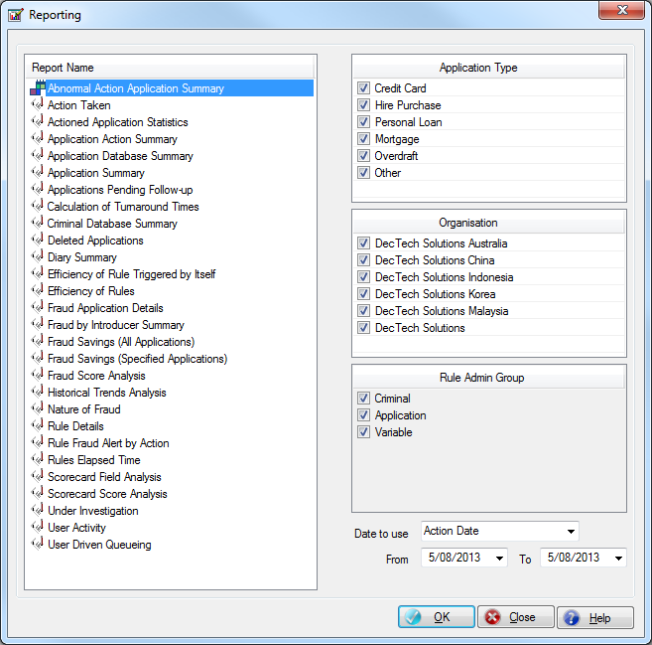

Abnormal Action Application Summary非正常申请确认报告

This report lists all the applications which have been actioned more than once.

该报告列出所有判定超过一次的申请记录。

Action Taken判定结果报告

This report provides the user with a breakdown of:

该报告包含如下信息：

* The number of HFP applications and the percentage of HFP applications;

高风险的申请记录数以及所占的百分比。

* The number of Suspect applications and the percentage of Suspect applications;

可疑的申请记录数以及所占的百分比。

* The number of Clean applications and the percentage of Clean applications;

清白的申请记录数以及所占的百分比。

* The total number of applications on the Application database.

申请数据库中的申请记录总数量

It then provides some additional information in regards to how each application within the above four categories were actioned:

而后提供为何以上四类申请被发现欺诈确认的一些附加信息：

* The number of known fraud applications and the percentage of known fraud applications;

判定为欺诈的申请记录数和所占的百分比。

* The number of applications under investigation and the percentage of applications under investigation;

调查中的申请记录数和所占的百分比。

* The number of false positive applications and the percentage of false positive applications;

疑似欺诈申请记录数和所占百分比。

* The number of suspicious applications and the percentage of suspicious applications;

无欺诈行为的申请记录数和所占的百分比。

* The number of applications not actioned and the percentage of applications not actioned.

还没有进行欺诈确认的申请记录数和所占的百分比。

Actioned Application Statistics[欺诈确认申请统计信息](mk:@MSITStore:D:\\MyDoc\\DecTech\\Acceptance%20Document\\Instinct\\Instinctcn.chm::/Reporting_Window.htm" \l "ActionedApps)

This report lists all the actioned applications which are displayed according to the day they were attended after being loaded in to Instinct.

该报告列出了所有确认为欺诈的申请，且这些申请可以根据日期来查询。

Application Action Summary申请欺诈确认摘要信息

This report lists all the actioned applications with application number, fraud alert, Investigation result and decision reason for data analysis.

该报告列出了所有欺诈确认的申请，并列出申请的申请号，欺诈警报，调查结果和决定原因来做数据分析。

Application Database Summary申请数据库摘要信息

This report provides the user with a summary of the types of category records on the Application database. It gives the total number of records on the database along with the earliest and latest application dates. It additionally provides the same breakdown but at the category level - the total number of records for each category along with the earliest and latest application dates for each category.这个报表提供申请数据库分类记录类型的概要。它给出一个日期区间中申请数据库的纪录总数。然后它给出具有不同分类水平的细目分账：在这个日期区间中对于不同分类的记录总数以及每个分类中最早和最新的申请日期。

Application Summary申请信息摘要

This report provides the user with a breakdown of the number of Application database records for each application date. It additionally provides a further breakdown of:

该报告提供了申请数据库记录的数量。同时另外提供了下列信息：

* The number of HFP applications and the percentage of HFP applications;

高风险的申请记录数以及所占的百分比。

* The number of Suspect applications and the percentage of Suspect applications;

可疑的申请记录数以及所占的百分比。

* The number of Clean applications and the percentage of Clean applications.

清白申请记录数以及所占的百分比

Applications Pending Follow-up[未进行欺诈确认申请信息](mk:@MSITStore:D:\\MyDoc\\DecTech\\Acceptance%20Document\\Instinct\\Instinctcn.chm::/Reporting_Window.htm" \l "PendingApps)

This report provides a summary of applications that are in Suspect and HFP queue with the diary note which is added by user but not being actioned yet.

该报告提供了在疑似欺诈和高风险队列中，用户尚未判定的纪录概要和日志记录。

Calculation of Turnaround Times计算周转时间

This report lists the total applications created in the HFP/Suspect/Clean queue and the number of actioned applications that were actioned within the required number of days on a monthly basis:

这个报表列出高风险/可疑/无风险队列中全部申请和全部没有欺诈确认的申请，以及特定月内需要天数内被欺诈确认的申请个数：

* The number of HFP applications that were actioned within the required days.

所需天数内用户已判定高风险申请数量。

* The percentage of HFP applications that were actioned within the required days.

所需天数内用户已判定高风险申请的百分比。

* The number of Suspect applications that were actioned within the required days.

所需天数内用户已判定疑似欺诈申请数量。

* The percentage of Suspect applications that were actioned within the required days.

所需天数内用户已判定疑似欺诈申请百分比。

* The number of Clean applications that were actioned within the required days.

所需天数内用户已判定清白申请数量。

* The percentage of Clean applications that were actioned within the required days.

所需天数内用户已判定清白申请百分比。

* The number of HFP applications

高风险申请数量

* The number of Suspect applications

疑似欺诈申请数量

* The number of Clean applications

清白申请数量

Criminal Database Summary欺诈数据库摘要信息

This report provides the user with a summary of the types of category records on the Criminal database. It gives the total number of records on the database along with the earliest and latest application dates. It additionally provides the same breakdown but at the category level - the total number of records for each category along with the earliest and latest application dates for each category.这个报表提供欺诈数据库分类记录类型的概要。它给出一个日期区间中罪犯数据库的纪录总数。然后它给出具有不同分类水平的细目分账：在这个日期区间中对于不同分类的记录总数以及每个分类中最早和最新的申请日期。

Deleted Applications删除的申请

This report lists all the deleted applications within the specific period.

该报告列出了在指定的期间删除的申请。

Diary Summary日志摘要

This report lists all the diary notes for a selected date range and selected application numbers.

该报告列出了所有的日志，用来选择日期范围和选择申请数量。

Efficiency of Rules欺诈规则效率

This report lists all of the rules that have been triggered by Instinct. Each rule is in turn broken down into:

该报告列出了所有的Instinct触发的规则。每一条规则又分为：

* The number of applications that the rule was triggered for;

触发规则的申请数量

* The number of times that the rule was triggered;

规则触发的次数

* The number of HFP applications that the rule was triggered for and the percentage of HFP applications;

触发规则的高风险申请数量和百分比

* The number of Suspect applications that the rule was triggered for and the percentage of Suspect applications;

触发规则的疑似欺诈申请数量和百分比

* The number of Clean applications that the rule was triggered for and the percentage of Clean applications;

触发规则的清白申请数量和百分比

* The number of known fraud applications that the rule was triggered for and the percentage of known fraud applications;

触发规则的确认欺诈申请数量和百分比

* The number of applications under investigation that the rule was triggered for and the percentage of applications under investigation;

触发规则的在调查中申请数量和百分比

* The number of false positive applications that the rule was triggered for and the percentage of false positive applications;

触发规则的在确认清白申请数量和百分比

* The number of suspicious applications that the rule was triggered for and the percentage of suspicious applications;

触发规则的在确认疑似欺诈申请数量和百分比

* The number of applications not actioned that the rule was triggered for and the percentage of applications not actioned.

触发规则的未判定申请数量和百分比

Efficiency of Rule Triggered by Itself规则自己触发的功效

This report lists all of the rules that have been triggered by Instinct where the rule was triggered by itself. Each rule is in turn broken down into:

该报告列出了Instinct触发的规则，这些规则依靠它自己触发。每条规则分为：

* The number of applications that triggered this rule by itself;

自触发规则的申请数；

* Active Flag;

激活标志；

* The number of known fraud applications that the rule was triggered for;

触发此规则的确认欺诈申请数量；

* The number of suspicious applications that the rule was triggered for;

触发此规则的疑似欺诈申请数量；

* The number of false positive applications that the rule was triggered for;

触发此规则的清白欺诈申请数量；

* The number of applications under investigation that the rule was triggered for;

触发此规则的清白欺诈申请数量；

* Percentage of known fraud applications.

确认欺诈申请的百分比。

Fraud Application Details欺诈申请详情

This report lists all of the application details of all the applications that have been actioned as a known fraud along with the user id of the person who actioned the application, the date the action was taken and any fraud rules that were triggered by Instinct.

该报告列出了所有的确认欺诈申请详情，其中包括判定此申请的用户ID，判定日期和触发的规则。

Fraud By Introducer Summary介绍人欺诈摘要

This report summarises by introducer all the applications that have been actioned as a known fraud.

该报告将生成那些通过介绍人进行欺诈的申请记录的摘要信息。

Fraud Savings (All Applications)欺诈收益报告（所有申请）

This report lists all the applications that have been actioned as a known fraud so that you are able to determine the savings that Instinct has made for your organisation.

该报告将列出所有确认为欺诈行为的申请记录信息，这样可以评估Instinct为您企业降低了多少欺诈风险。

Fraud Savings (Specified Applications)欺诈收益报告（指定的申请）

This report lists the applications that have been actioned as a known fraud and specified for inclusion as a fraud saving.

该报告将列出在确认欺诈行为时用户所指定纳入该报表的申请记录信息，这样可以评估Instinct为您企业降低了多少欺诈风险。

Fraud Score Analysis欺诈积分分析

This report groups the fraud scores of all the applications on the Application database into a maximum of ten score band ranges. Each score band is in turn broken down into:该报告根据申请数据库中的所有申请记录的欺诈分数进行分组，最大每十分为一组，每组分数中都包含如下信息的统计内容–

* The number of known fraud applications;

确认欺诈的申请数量;

* The number of applications under investigation;

在调查中的申请数量;

* The number of false positive applications;

清白的申请数量;

* The number of suspicious applications;

疑似欺诈申请的数量;

* The number of applications not actioned;

未判定的申请数量;

* The total number of applications on the Application database and the percentage of applications for each score band;

申请数据库中所有申请数量和每个分数段中的申请百分比;

* The fraud rate as a percentage of the total number of applications for each scoreband.

每个分数段中确认为欺诈行为的申请记录所占的百分比;

Historical Trends Analysis历史趋势分析

This report lists all of the rules that have been triggered by Instinct. The Application Date of each application that triggered the rule and the matched application is compared and broken down into:

该报告列出了Instinct触发的所有规则。触发规则的申请的日期，匹配的申请被比较和细分为：

* The number of matches where the difference is >= 1 day;

时间差>=1天的匹配的数量;

* The number of matches where the difference is between 0 and 30 days in the past;

时间差在过去的0到30天之间的匹配数量;

* The number of matches where the difference is between 31 and 60 days in the past;

时间差在过去31到60天之间的匹配数量;

* The number of matches where the difference is between 61 and 90 days in the past;

时间差在过去61到90天之间的匹配数量;

* The number of matches where the difference is between 91 and 120 days in the past;

时间差在过去91到120天之间的匹配数量;

* The number of matches where the difference is between 121 and 150 days in the past;

时间差在过去121到150天之间的匹配数量;

* The number of matches where the difference is between 151 and 180 days in the past;

时间差在过去151到180天之间的匹配数量;

* The number of matches where the difference is >= 181+ days in the past;

时间差大于181天的匹配数量;

* The total number of matches.

所有匹配的数量;

Nature of Fraud欺诈分类

This report summarises the Nature of Fraud for all the applicants for all the applications that have been actioned as known fraud.

该报告总结了所有被确认为欺诈的申请中的欺诈分类。

Rule Details规则细节

This report lists all the rules triggered by Instinct which include the detailed define information for each rule. Each rule is broken down into:

该报告列出了Instinct触发的规则，其中包含了每一条规则详细的定义信息。每条规则细分为：

* The active flag for each rule.

每条规则的活动标识

* The fraud score for each rule.

每条规则的欺诈得分

* The user id who created the rule.

创建规则的用户ID

* The date and time on which the rule was created.

规则创建日期和时间

* The user id who last updated the rule.

最后修改规则的用户ID

* The date and time on which each rule was last updated.

最后修改规则的日期和时间

Rule Fraud Alert by Action[按规则进行欺诈确认及报警统计](mk:@MSITStore:D:\\MyDoc\\DecTech\\Acceptance%20Document\\Instinct\\Instinctcn.chm::/Reporting_Window.htm" \l "FraudAlertByAction)

This report lists all of the rules that have been triggered by Instinct. Each rule is in turn broken down into:

该报告列出了Instinct触发的规则。每条规则细分为：

* The number of HFP applications that were actioned as Known Fraud.

高风险申请被确认欺诈的数量

* The number of Suspect applications that were actioned as Known Fraud.

疑似欺诈申请被确认欺诈的数量

* The number of Clean applications that were actioned as Known Fraud.

清白申请被确认欺诈的数量

* The number of HFP applications that were actioned as Under Investigation.

高风险申请被确认为在调查中的数量

* The number of Suspect applications that were actioned as Under Investigation.

疑似欺诈申请被确认为在调查中的数量

* The number of Clean applications that were actioned as Under Investigation.

清白申请被确认为在调查中的数量

* The number of HFP applications that were actioned as False Positive.

高风险申请被确认为无欺诈的数量

* The number of Suspect applications that were actioned as False Positive.
* 疑似欺诈申请被判定为无欺诈的数量。
* The number of Clean applications that were actioned as False Positive.

清白申请被判定为无欺诈的数量。

* The number of HFP applications that were actioned as Suspicious.

高风险申请被确认为疑似欺诈的数量。

* The number of Suspect applications that were actioned as Suspicious.

疑似欺诈申请被确认为疑似欺诈的数量

* The number of Clean applications that were actioned as Suspicious.

清白申请被确认为疑似欺诈的数量

Rule Elapsed Time规则耗时报表

This report shows the time in milliseconds taken for applications to pass through the Active Instinct rules.

此报表展示了每条激活规则的执行时间，精确到毫秒。

Scorecard Field Analysis评分卡字段分析

This report reapplies each scorecard attribute against the Application database for each of the assigned scorecards. Each scorecard field and attribute is listed and a break down is provided of:

该报告将对申请数据库重新应用每个积分卡属性，然后列出每个积分卡的字段和属性，并给出进一步的汇总信息

* The number of known fraud applications for each scorecard attribute;

每个积分卡属性对应的具有欺诈行为的申请记录数量

* The number of applications under investigation for each scorecard attribute;

每个积分卡属性对应的处于调查中的申请记录数量

* The number of false positive applications for each scorecard attribute;

每个积分卡属性对应的无欺诈行为的申请记录数量

* The number of suspicious applications for each scorecard attribute;

每个积分卡属性对应的处于疑似欺诈的申请记录数量

* The number of applications not actioned for each scorecard attribute;

每个积分卡属性对应的还没有进行欺诈行为确认的申请记录

* The total number of applications on the Application database and the percentage of applications for each scorecard attribute;

每个积分卡属性对应的总申请记录数以及所占的百分比

* The fraud rate as a percentage of the total number of applications for each scorecard attribute.

每个积分卡属性对应的具有欺诈行为的申请记录所占的百分比

Scorecard Score Analysis评分卡分值分析

This report groups the scorecard scores of all the applications on the Application database into a maximum of ten score band ranges. Each score band is in turn broken down into:该报告根据申请数据库中的所有申请记录的积分卡分数进行分组，每十分为一组，每组分数中都包含如下信息的统计内容：

* The number of known fraud applications;

判定为欺诈行为的申请记录数

* The number of applications under investigation;

判定为调查中的申请记录数

* The number of false positive applications;

判定为无欺诈行为的申请记录数

* The number of suspicious applications;

判定为疑似欺诈申请记录数

* The number of applications not actioned;

未进行确认的申请记录数

* The total number of applications on the Application database and the percentage of applications for each score band;

对于每一个分数段所包含的总申请记录数以及所占的百分比

* The fraud rate as a percentage of the total number of applications for each score band.

每个分数段中确认为欺诈行为的申请记录所占的百分比

Under Investigation在调查中

This report lists all the applications that are Under Investigation within a specified date range.

该报告列出了指定日期范围内所有在调查中的申请

User Activity用户行为

This report lists all the users of Instinct that have actioned applications and the total number of applications that they have actioned for any given period. It includes a breakdown of the action that the user took.

这个报表列在指定期间内Instinct中所有判定过欺诈确认的用户及他们欺诈确认申请的总数。这个报表罗列出指定日志时间段的全部申请的详细资料，日志日期，日志时间，用户标识和日志记录。

User Driven Queueing用户驱动队列报表

This report details how many applications were assigned to each team and/or user including the details of how many were actioned within the warning and expiry minutes, how many were reassigned and how many are still under investigation.

该报表详细列出了有多少申请被分配到每一个小组或者用户。包括多少申请在警告和过期时间范围内的，多少申请被重新分配以及多少申请仍在调查中。

3.4.2 SQL ReportsSQL报表

SQL Reports can be used to generate customised reports in terms of the specified requirements. The SQL script has been encrypted and the filter used to generate the report can be defined separately:

SQL报表为特定的需要生成定制的报表。SQL脚本将被加密，用来生成报表的过滤器将被单独定义：

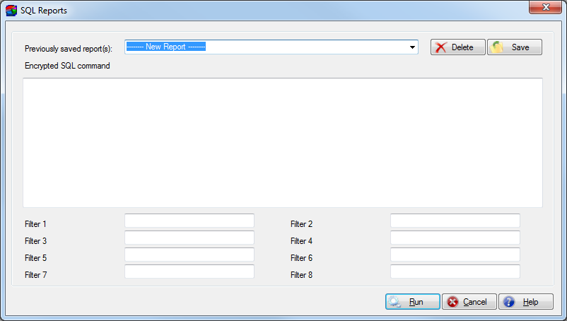

3.4.3 List Report列表报表

List report allows the user to create their own reports based on a Criteria and all fields available in Instinct. Users can also set up list report templates for regular reporting purposes.

根据查询规则和Instinct可用的字段，列表报表允许用户创建他们自己的报表。用户可以创建列表报表模板，用于定期使用报表。

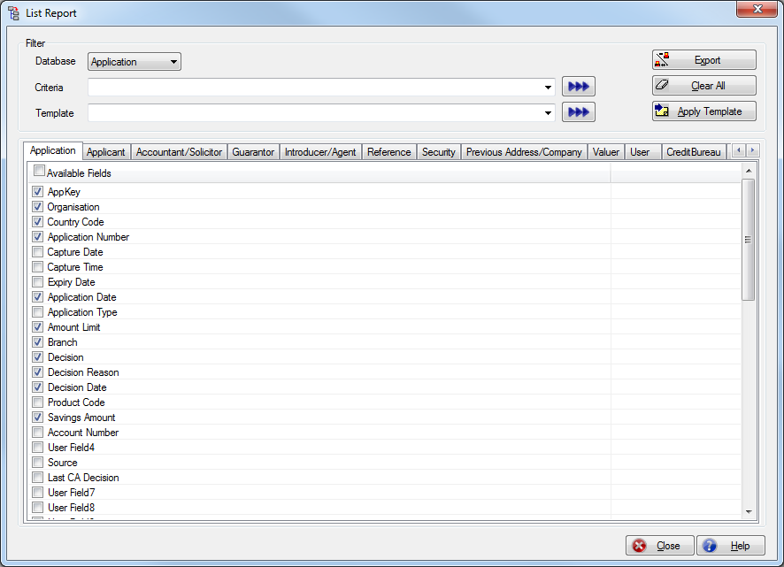

3.4.4 Batch Report批量报表

Batch Report allows users to schedule the generation of the standard reports on a daily, weekly or monthly basis. Reports can be generated into a central location or emailed to a user or distribution group. Batch reports require the communication service.

批量报表使用户可以按计划每日/每周/每月生成标准报表。报表可以生成到一个集中的地点或者email给用户或者分配的小组。批量报表需要通讯服务。

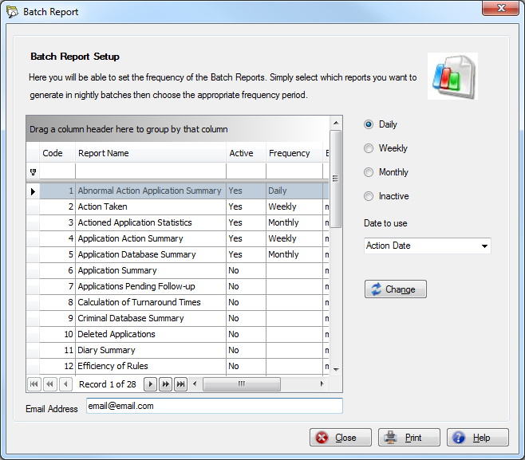

## Security Menu安全菜单

3.5.1 Profiles权限组

At a high level, users are assigned to a pre-defined profile. A profile is set up by the Administrator to determine which functions within Instinct the users can access. That access can be defined as:

用户可以分配预定义的权限组。管理员设置权限组来决定用户可以访问Instinct中的哪一部分功能。访问可以被定义为：

* Full (with or without Delete where appropriate);

完全访问（可以有删除权限）

* View (with or without Delete where appropriate);

浏览访问（可以有删除权限）

* None.

无权限

Additionally, passwords can be set up to expire after ‘x’ days, and session locking can be enabled if required (preventing the user from signing on to more than one PC at a time).

另外，系统还可以设置用户密码过期时间以及是否开启会话锁定功能（该功能可以防止用户在同一时间使用不同的计算机进行登陆）。

A profile is equivalent to an Active Directory group (when Instinct security is not used).

权限组相当于活动目录组（当Instinct安全机制未被使用）。

The following screen shows how profiles are defined. The Expire Password period and the Session Locking parameters are not applicable when Instinct security is not used.

下列界面显示了权限组如何被定义的。当Instinct安全机制未被使用时，密码过期时间和会话锁参数不可用。

DecTechwill set the following profiles in Instinct:

DecTech将会设置如下的权限组

1. Security - define access, users
2. Fraud analysts - maintain rules, update criminal database(optional)
3. Fraud reviewer - review alerts
4. MIS - operational reporting, analytical reporting
5. Investigations, update criminal database(optional)
6. Recoveries

If Instinct security is not used, Application Type security access will be available at the profile or group level – this determines what type of applications the user can add, update and action.

如果Instinct安全机制未被使用，申请类型安全访问在权限组或者组别级别是可用的-这决定哪种类型的申请用户可以新增，修改和判定。

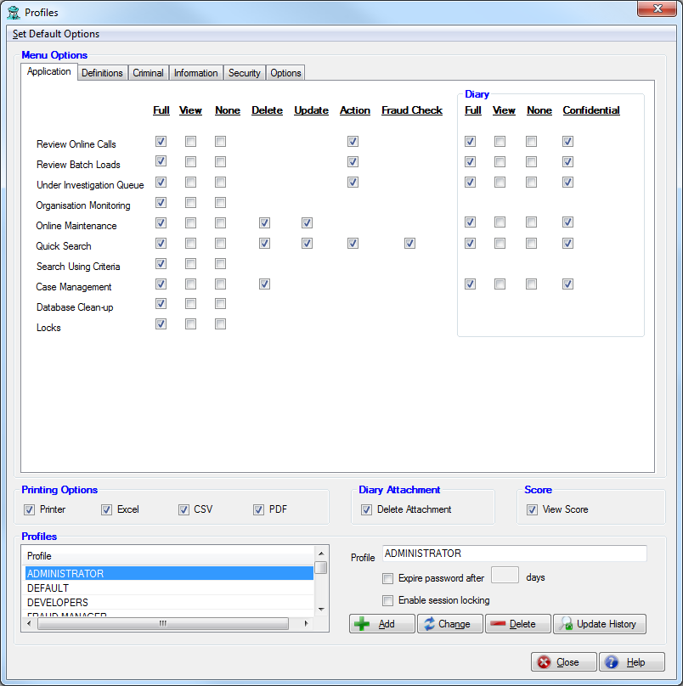

3.5.2 Users用户

At an individual level, users are assigned to a profile and then given access to different application types within Instinct:

每个使用Instinct的用户都会被分配一个权限配置文件，同时需要分配他们可以访问的申请类型。

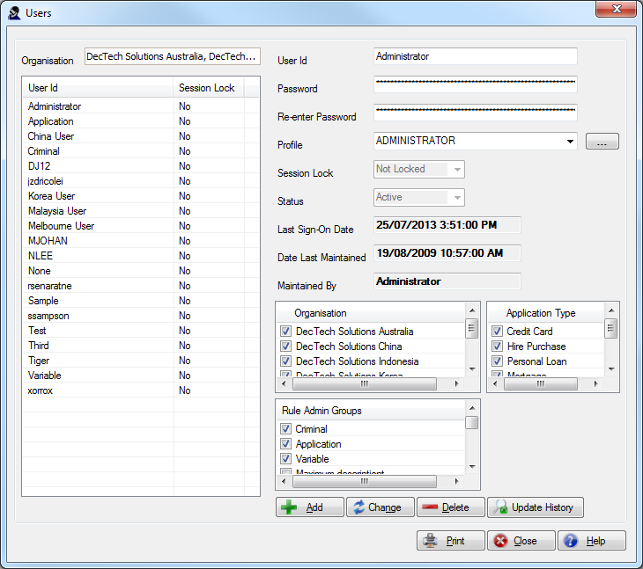

The User screen will be disabled and the User Id from Active Directory will be usedif Instinct security is not used.

如果Instinct安全机制未被使用，用户界面将不可用而来自活动目录中的用户ID会被使用

3.5.3 Change Password修改密码

The user may change their password at any time using the Change Password function:

用户可使用密码修改功能在任意时刻修改他们的密码。

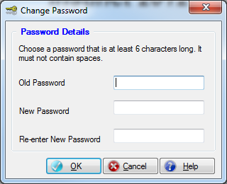

The Change Password screen will be disabled if Instinct security is not used.

如果Instinct安全选项没有使用，修改密码窗口不会被激活。

3.5.4 Security Parameters安全参数

All security parameters can be maintained by the security administrator:

安全管理员维护所有的安全参数。

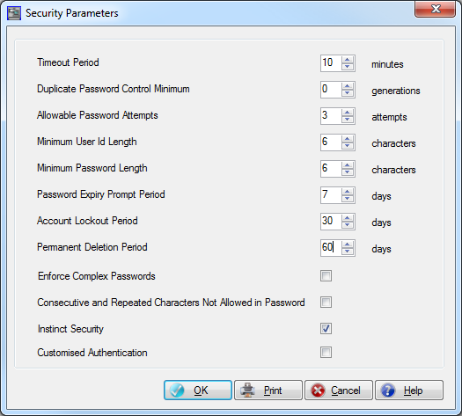

If the Use Instinct Security option is not checked it means the parameters related to password control become not relevant.

如果使用Instinct安全机制选项未被选中，那意味着与密码相关的参数无效。

| **Parameter** | **Value** |
| --- | --- |
| Timeout Period | 10 |
| Duplicate Password Control Minimum | 0 |
| Allowable Password Attempts | 3 |
| Minimum User Id Length | 6 |
| Minimum Password Length | 6 |
| Password Expiry Prompt Period | 7 |
| Account Lockout Period | 30 |
| Permanent Deletion Period | 60 |
| Enforce Complex Passwords | Not ticked |
| Consecutive and Repeated Character Not Allowed In Password | Not ticked |
| Instinct Security | Ticked |
| Customised Authentication | Not ticked |
| User Id Maker Checker | Not ticked |

***3.5.5 Audit Log审核日志***

A comprehensive audit log lets the security administrator quickly and easily see ‘who did what’ in Instinct:

在Instinct中，全面的审核日志让安全管理员可以迅速和容易地查看“谁干了什么”

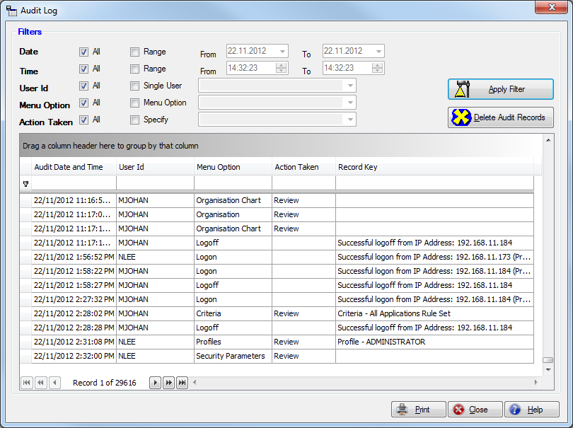

Any of the fields shown in the **Audit Log** window can be used as filters to produce an audit report. For example, the user can see an audit log of –

在审核日志窗口中的任意字段用来过滤生产地审核报告。例如,用户可以查看审核日志的：

* All dates, or a range of dates

所有数据，或者某一范围内的数据

* All times, or a range of times

所有的时间，或者某段时间

* All User Ids, or a single user id

所有的用户ID,或者单独的一个用户ID

* All menu options, or an individual menu option

所有的菜单选项，或者单独的一个菜单选项

* All actions taken, or an individual action

所有发生地操作，或者单独的一个操作

Additionally, the user (usually an Administrator, who has the appropriate authority) can choose to clean-up the audit log by deleting the filtered records if he or she has the appropriate permission to do so.

另外，如果用户（通常是拥有相应权限的管理员）拥有相应的许可，他（她）可删除在审核日志中过滤了的记录。

3.5.6 Maker Checker Mapping 复核映射

If the User Id Maker Checker option is enabled in the Security Parameters the Maker Checker Mapping window is enabled.

如果在安全参数中勾选了用户复核，复核映射窗口将被激活。

This allows users to map the maker and the checker for User Id maintenance.

这允许用户针对用户维护来设置创建人和复核人。

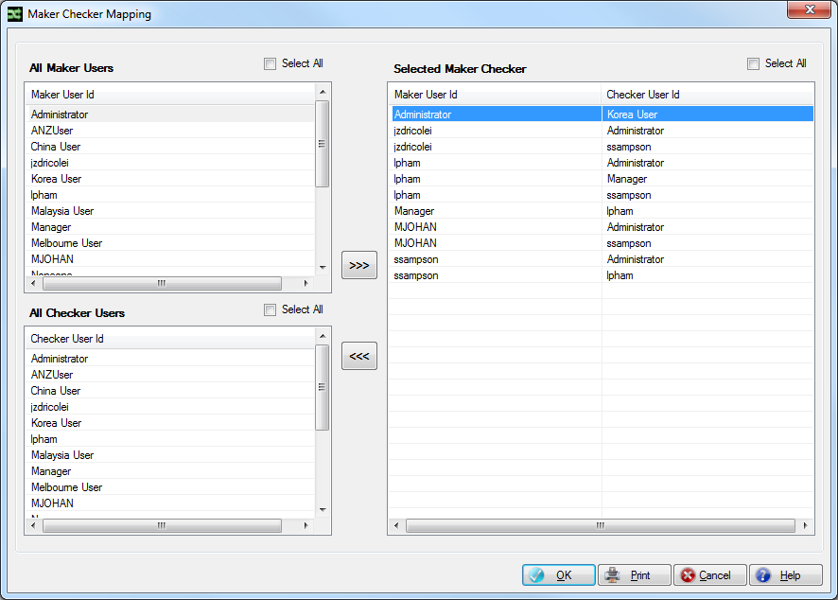

3.5.7 User Id Approval用户审核

The User Id Approval window displays the pending User Id changes, what changes were made, who they were made by and who can approve the changes.

用户审核窗口显示等待复核的用户修改。

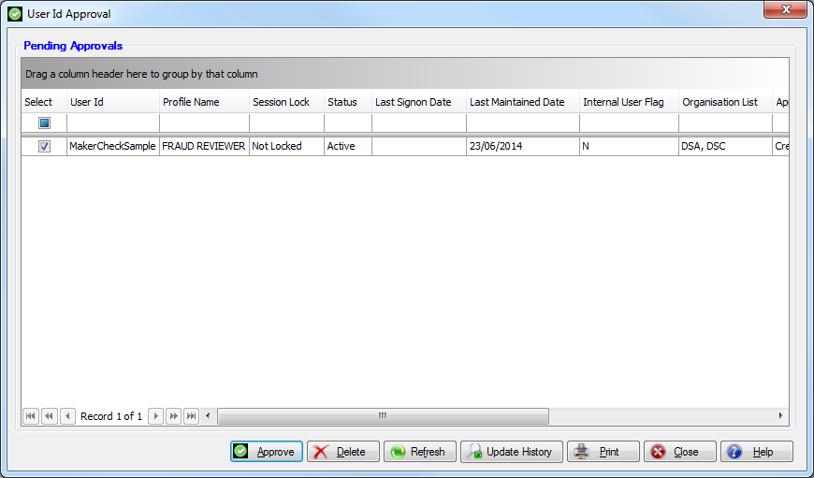

## System Options系统选项

3.6.1 System Parameters Maintenance系统参数维护

Client and Server parameters can be maintained on the System Parameters Maintenance window:

在系统参数维护窗口可以维护客户端和服务器参数。

Client Parameters客户端参数

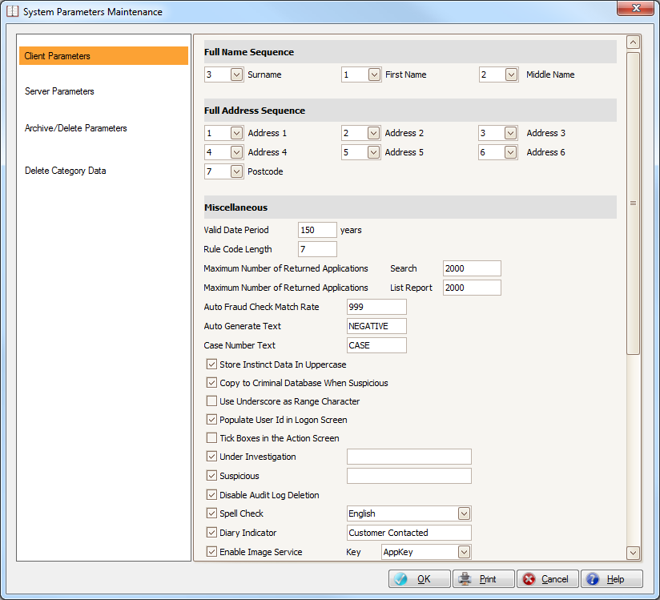

| **Parameter** | **Value** |
| --- | --- |
| Full Name Sequence | Surname (3), Middle Name (2), First Name (1) |
| Full Address Sequence | Address 1 (1), Address 2 (2), Address 3 (3), Address 4 (4), Address 5 (5), Address 6 (6), Postcode (7) |
| Valid Date Period | 150 |
| Rule Code Length | 7 |
| Maximum Number of Returned Applications Search | 2000 |
| Maximum Number of Returned Applications List Report | 2000 |
| Auto Fraud Check Match Rate | 1000 |
| Auto Generate Text | ‘NEGATIVE’ |
| Case Number Text | ‘CASE’ |
| Store Instinct Data In Uppercase | Not ticked |
| Copy to Criminal Database When Suspicious | Ticked |
| Use Underscore as Range Character | Not ticked |
| Populate User Id in Logon Screen | Ticked |
| Tick Boxes in Action Screen | Ticked |
| Under Investigation | Ticked |
| Suspicious | Ticked |
| Disable Audit Log Deletion | Not ticked |
| Spell Check | Ticked; English |
| Diary Indicator | Ticked; Customer Contacted (default) |
| Enable Image Service | Not ticked; Key AppKey |
| Rule Comments Mandatory | Not ticked |
| Show Rule Groups in Match Review | Not ticked |
| Disable Diary Not Clearing | Not ticked |
| Enable Alert Message Box | Not ticked |
| Dual Control on Rules Maintenance | Not ticked |
| Dual Control on Rule Sets | Not ticked |
| Remove from Criminal when Known Fraud re-actioned as False Positive | Ticked |
| Remove from Criminal when Suspicious re-actioned as False Positive | Ticked |
| Number of Recent Applications | 10 |
| Number of Recent Cases | 10 |
| Number of Recent Criminal | 10 |
| Email Address Domain |  |
| Enable Memo | Not ticked |
| Known Fraud Label |  |
| Disallow Rule Copy Overwrite | Not ticked |
| Enable White List | Not ticked |
| Under Investigation Prompt Upon Logon | Not ticked |

Server Parameters服务器参数

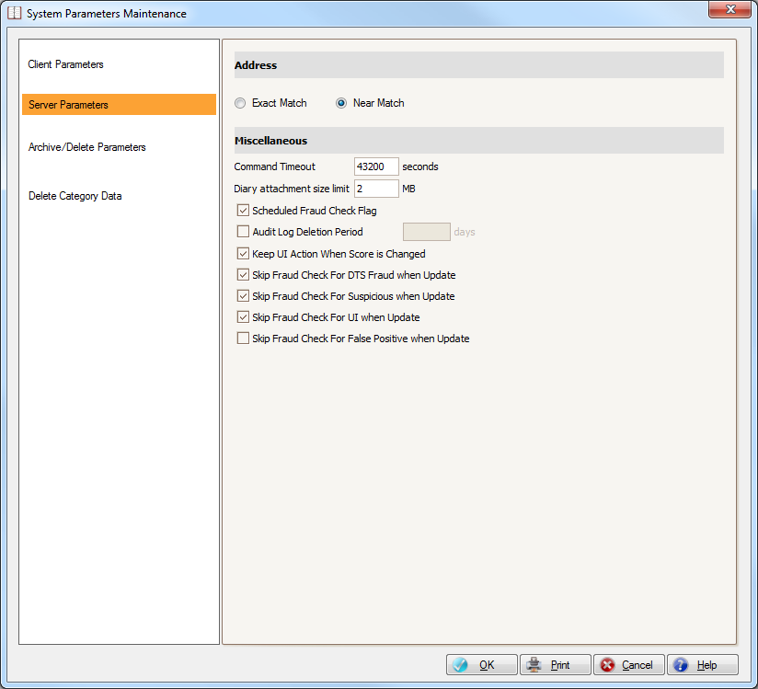

| **Parameter** | **Value** |
| --- | --- |
| Address | Exact Match |
| Command Timeout | 600 |
| Diary attachment size limit | 2 |
| Scheduled Fraud Check Flag | Ticked |
| Audit Log Deletion Period | Not ticked |
| Keep Under Investigation Action When Score is Changed | Ticked |
| Skip Fraud Check For Known Fraud when Update | Ticked |
| Skip Fraud Check For Suspicious when Update | Ticked |
| Skip Fraud Check For Under Investigation when Update | Not ticked |
| Skip Fraud Check for False Positive when Update | Not ticked |

Archive/Delete Parameters归档/删除参数

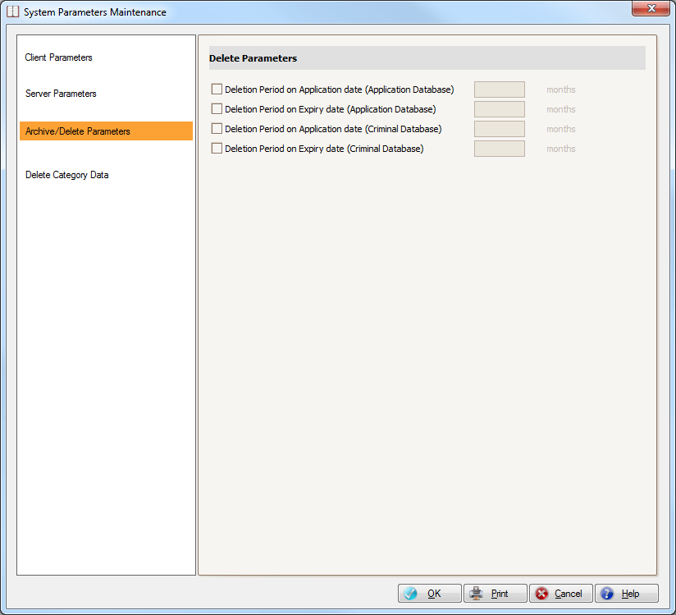

| **Parameter** | **Value** |
| --- | --- |
| Deletion Period on Application Date (Application Database) | Not ticked |
| Deletion Period on Expiry Date (Application Database) | Not ticked |
| Deletion Period on Application Date (Criminal Database) | Not ticked |
| Deletion Period on Expiry Date (Criminal Database) | Not ticked |

Delete Category Data删除分类数据

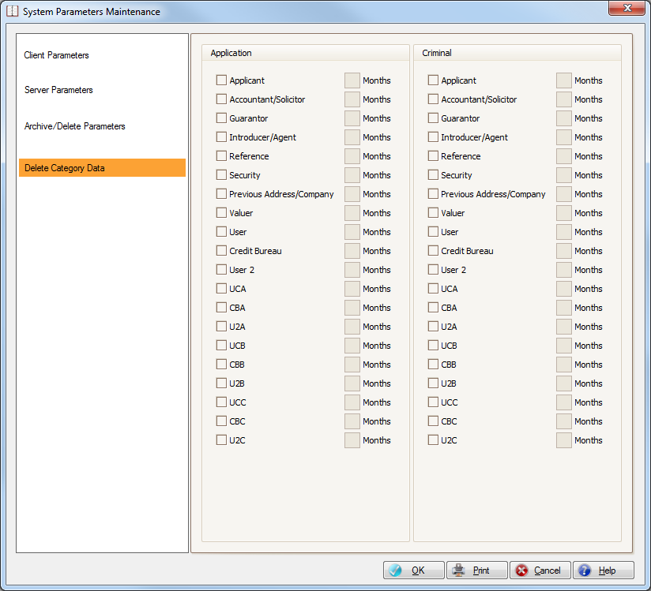

| **Parameter** | **Value** | **Parameter** | **Value** |
| --- | --- | --- | --- |
| **Application Database** |  | **Criminal Database** |  |
| Applicant | Not ticked | Applicant | Not ticked |
| Accountant/Solicitor | Not ticked | Accountant/Solicitor | Not ticked |
| Guarantor | Not ticked | Guarantor | Not ticked |
| Introducer/Agent | Not ticked | Introducer/Agent | Not ticked |
| Reference | Not ticked | Reference | Not ticked |
| Security | Not ticked | Security | Not ticked |
| Previous Address/Company | Not ticked | Previous Address/Company | Not ticked |
| Valuer | Not ticked | Valuer | Not ticked |
| User | Not ticked | User | Not ticked |
| Credit Bureau | Not ticked | Credit Bureau | Not ticked |
| User 2 | Not ticked | User 2 | Not ticked |
| UCA | Not ticked | UCA | Not ticked |
| CBA | Not ticked | CBA | Not ticked |
| U2A | Not ticked | U2A | Not ticked |
| UCB | Not ticked | UCB | Not ticked |
| CBB | Not ticked | CBB | Not ticked |
| U2B | Not ticked | U2B | Not ticked |
| UCC | Not ticked | UCC | Not ticked |
| CBC | Not ticked | CBC | Not ticked |
| U2C | Not ticked | U2C | Not ticked |

3.6.2 Field Requirements字段要求

In Instinct the fields may be labeled specifically for the client. For example, Applicant Id Number 1 may be labeled ‘Drivers License Number’:

在Instinct的字段可能在客户端程序中是一个特殊的标签。例如：Applicant Id Number 1可能为“‘Drivers License Numbe”标签：

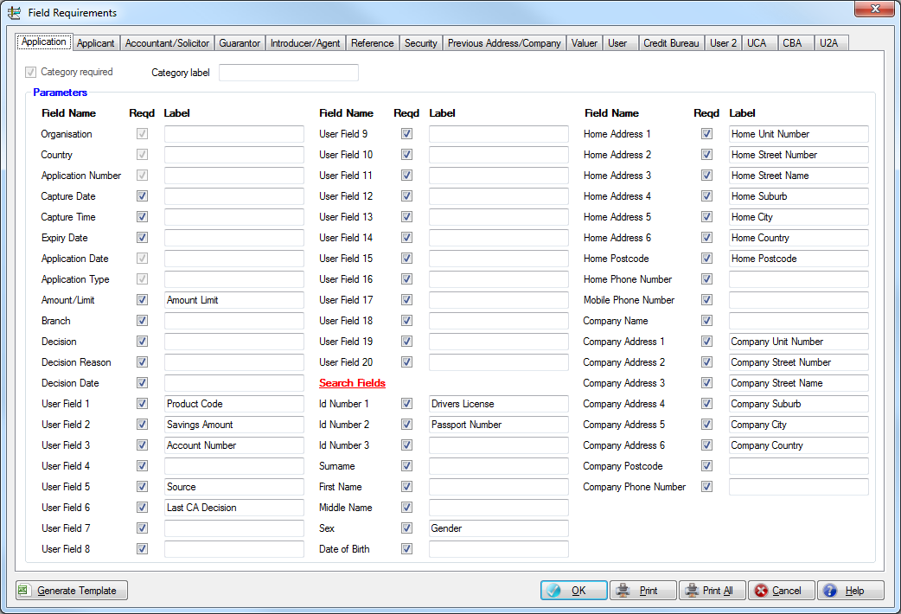

3.6.3 Auto Load Options自动装载选项

When using Instinct in batch mode, or for the historical data load, the size of the batch can be specified down to the application type level:

当使用Instinct批处理模式，或者历史数据装载时，可指定一批数据的大小：

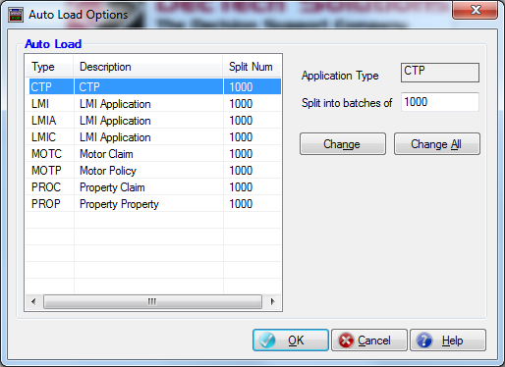

3.6.4 Auto Fraud Check Fields Requirements自动欺诈检查字段要求

The fields which are required to be auto-fraud checked can be specified by the user:

用户可以指定需要在自动欺诈检查中使用的字段。

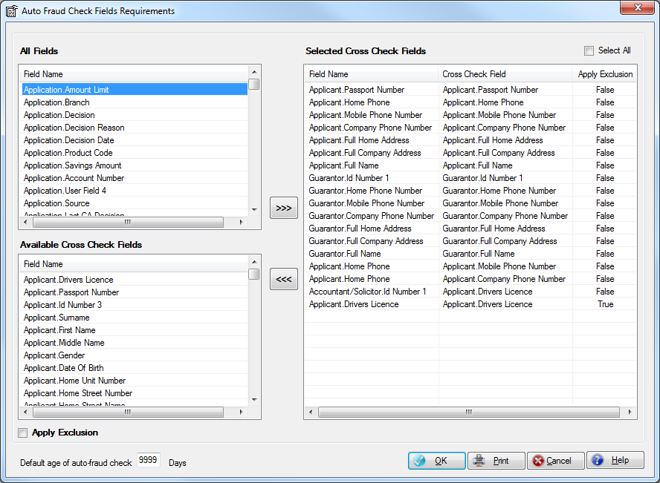

3.6.5 Fraud Savings Report Fields Requirements欺诈收益报告字段需求

The fields which are required to be displayed on the fraud savings reports can be specified by the user (in addition to the standard fields):

用户可以指定需要显示在欺诈收益报告中的字段。

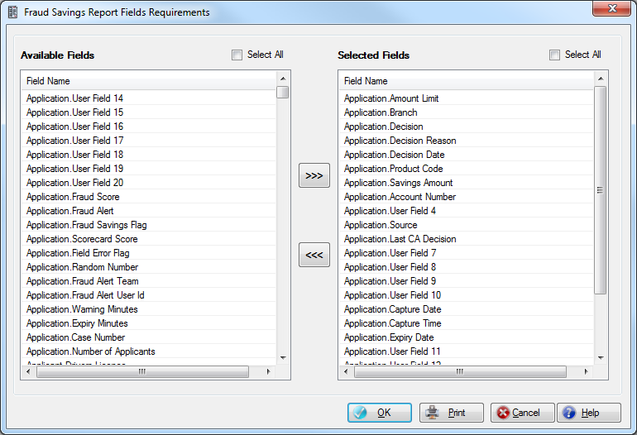

3.6.6 Action Fields Requirements判定字段需求

The Action Fields Requirements window is used to pre define the fields selected in the action window when a particular Decision Reason is selected.

判定字段需求界面用来预定义在判定窗口中选择当特定决定原因被选择时显示的字段。

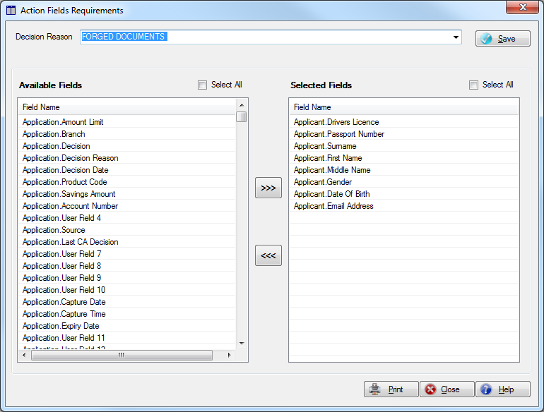

3.6.7 Fields Retention字段保留

The Fields Retention window allows the userto specify which fields will be retained in Instinct should an update occur on any application that matches the Criteria used.

字段保留窗口允许用户指定哪个Instinct中的字段会在更新发生时保留以前的值，可以指定一个过滤条件，指定特定的申请保留字段。

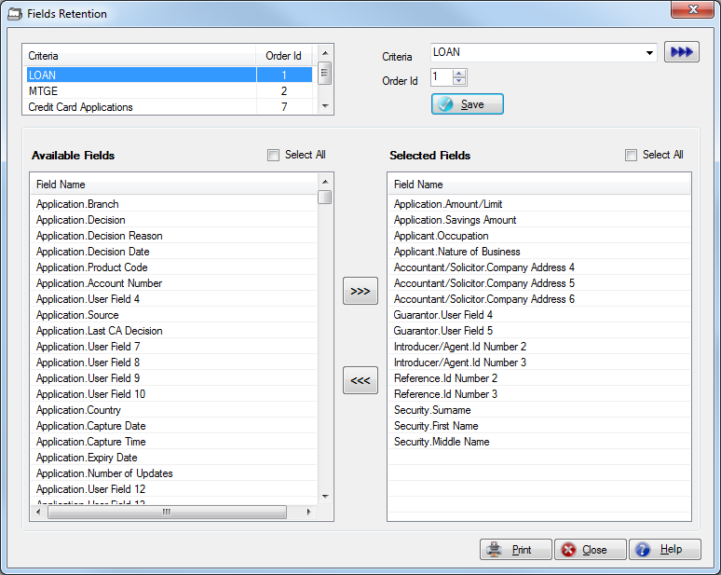

3.6.8 Alert Message Box User Criteria警告消息用户查询规则

The Alert Message Box User Criteria allows the user to set up the parameters for the alerts to be shown on the Alert Message box.

警告消息用户查询规则允许用户创建此参数设置报警消息框。

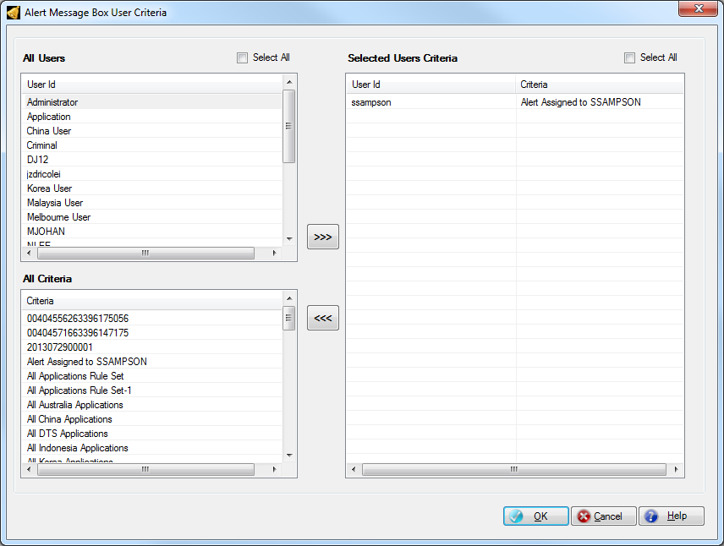

3.6.9 Auto Action Criteria自动判定条件规则

The Auto Action Criteria window allows the user to set up the criteria and action for the system to automatically action applications as they are loaded into Instinct.

自动判定条件规则窗口允许用户创建条件规则和判定来自动判定申请。

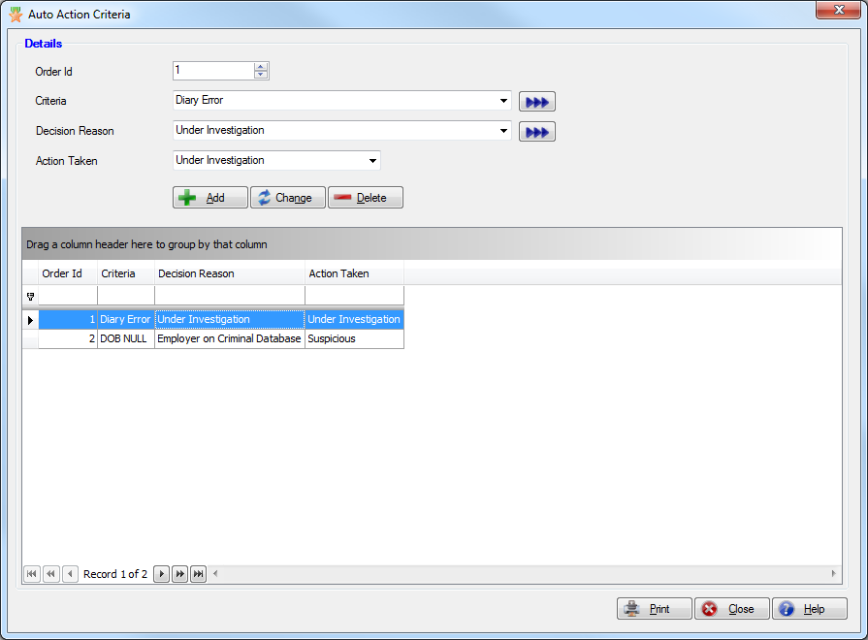

## Online Help在线帮助

Instinct features an online help system which is an online user manual, including context-sensitive help.

Instinct提供在线帮助系统，它是一个在线用户指南，包括上下文相关的帮助。

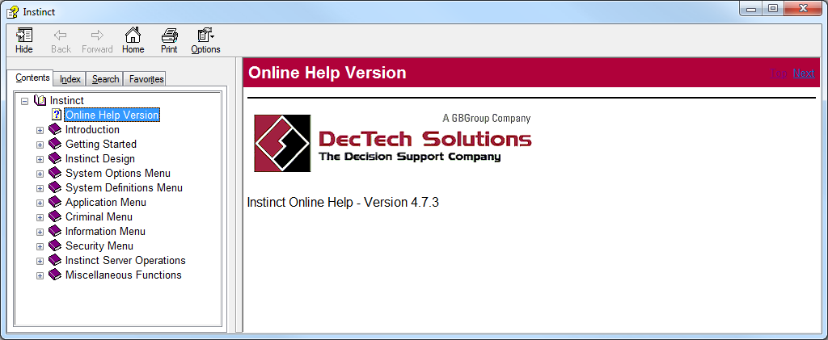

# Sign-off

DRC accepts this Business Specification as an accurate representation of the business requirements for the implementation of Instinct at DRC China.

东莞农商同意此业务说明书正确地描述了Instinct系统需要在东莞农商实现的业务需求。

###### **ACCEPTANCE同意**

________________________________________

AuthorisedSignatory授权签名

________________________________________

Name姓名

________________________________________

Title职务

________________________________________

Date日期